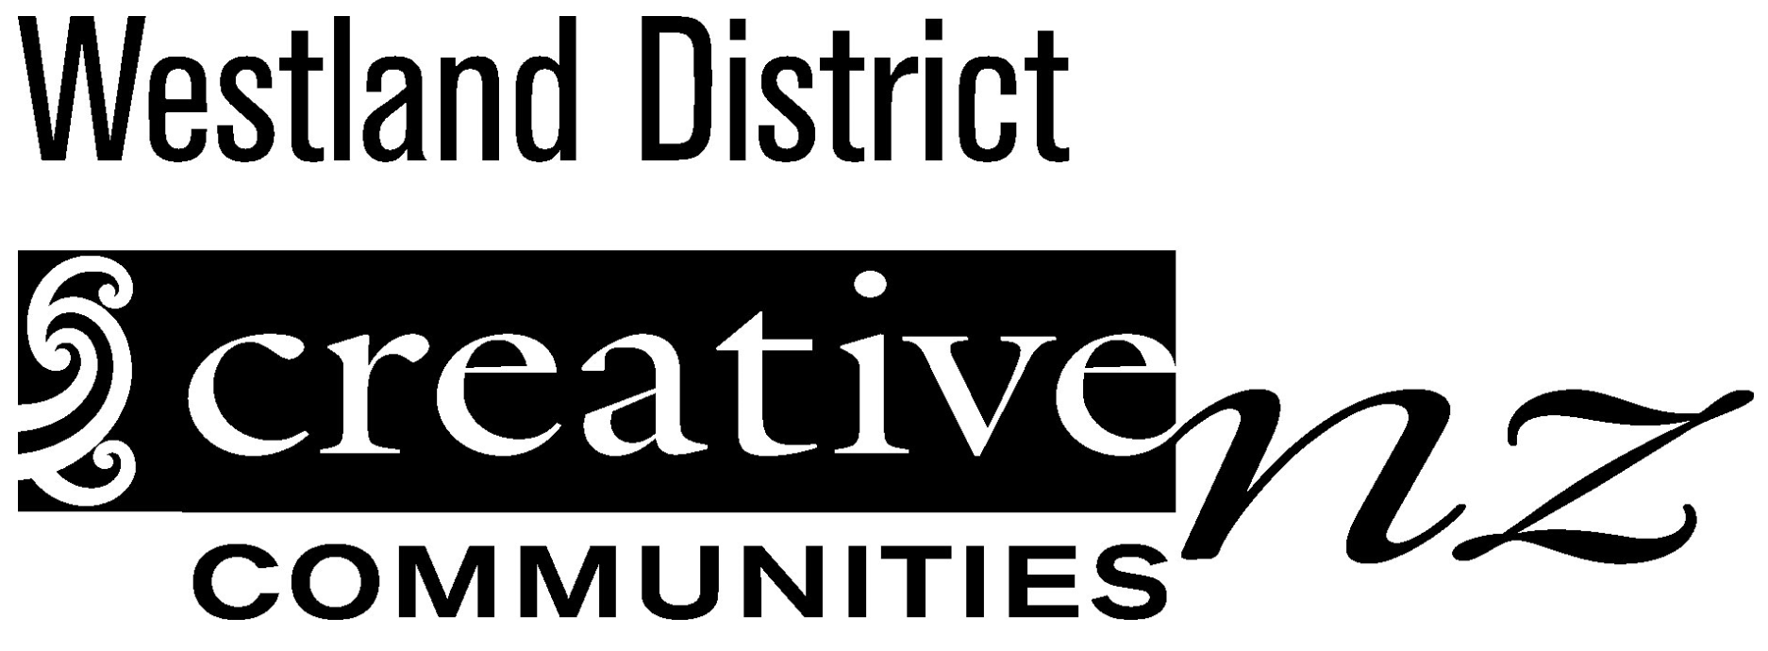

Assessment Committee Nomination Form for Election of
Westland District Creative Communities NZ Committee Members
Name of person making the nomination:
Name of organisation
If applicable:
Phone or mobile number:
Address:

Email:
Signature:

Date:

I nominate_______________________________ for the position of
Community representative on the Westland District Creative Communities Scheme Assessment Committee.

I __________________________________ accept the nomination.

Name:

Phone or mobile number:
Address:

Email:
Signature:

Role of Assessment Committee
Assessment committees are the heart of the success of the Creative Communities Scheme (CCS).
The Committee’s main role is assessing applications and allocating funding, in line with any specific local priorities set by Council.

The assessors (the members of the assessment committee) should have a broad knowledge of the arts environment in their local area.

Other functions of committee members include:
- Receiving reports on funded projects and discussing completed projects
- Attending performances, exhibitions and other events funded by Creative Communities scheme
- Discussing and making recommendations for promoting the scheme locally
- Attending meetings organised by Creative New Zealand
- Contributing to the annual evaluation report to Creative New Zealand
- Electing community representatives

Membership and make-up of assessment committees
The CCS assessment committee is an independent community group, not a council committee.
Its membership (apart from Council representatives) will be confirmed at the Community Development Committee. Decisions made by this committee are reported to the Community Development Committee, but do not need to be approved or confirmed by the Council.

Size of the Committee
There is no specific requirement for how many members an assessment committee must have. However, Creative New Zealand strongly recommends that there be at least seven, and not more than 11 members. A committee of nine members works well; having an odd number also assists with voting.

Term of Membership
Committee members may be appointed or elected for a specified term of not more than three years.
Members can serve a maximum of two consecutive terms.

It is a good idea to have a combination of new and experienced members. To keep this balance Creative Communities recommend that committee members be replaced over time.

Who sits on the Committee?
Each assessment committee consists of
- Community representatives; and
- Representatives from local Council; local Iwi or Hapu; and Community Arts Councils

Community representatives
Community representatives on the assessment committee must be familiar with the range and diversity of local arts activities. Ideally membership of the committee should also reflect the diverse groups in the local community – for example, young people, recent migrants, Asian residents and local Māori and Pasifika peoples
Members will be advised of their obligation to declare any conflicts of interest they might have in respect to applications, and to remove themselves from the discussion and allocation of funds.
